**SOUTHAMPTON SOLENT UNIVERSITY**

BSc (Hons) Computing Computing

UX STRATEGIES

Solent Alumni Programme System

Author: 10152420

Assessment Title: Solent Alumni Programme System

**Module Title: UX Strategies**

*****GitHub:*** *https://github.com/sarkersh/UX-Strategies***

**Table of Contents**

Introduction to system 2

Market research study 2

User research analysis 4

Contextual interview 4

User journey 6

User Persona 6

User Scenario 7

User Goals 8

Information Architecture 8

Empathy Mapping 9

Usability Metrics 9

Prototype 11

Usability testing 11

Conclusion 13

References 14

Appendices 15

Appendix 1: Contextual Interview 15

Appendix 2: Survey 16

Appendix 3: Usability Testing 19

# Introduction to system

The context of the project is to analyse the UX strategies of Solent University Alumni Association (SUAA) website and determine the issues being faced by the organization for implementing proper fixes for the issues. The Solent University Alumni Association (SUAA) website (https://www.solent.ac.uk/alumni) has been provided users with the proper platform for engaging in the learner community but several users are raising issues of inefficient website (https://www.solent.ac.uk/alumni) design that is making the tasks rather difficult for the users. The users of the website are any individual who have completed their study from Solent University and are placed in rather prestigious places in their work. The website is being developed for providing information easily on benefits, the methods of engaging as well as showcasing the achievements of the alumni in their respective years of studies. The system being considered is that new website that would be created for the users to gain knowledge about the prestigious alumni and their achievements in the respective fields. The website is being developed for simplifying the process of browsing through the various web pages and discovering information about the alumni to understand the values of Solent University and the intentions of the Solent University. The main issue being faced by the users in the present times is that the website has a rather unclear information presentation on the website and does not allow the users to easily browse through the various sections of the website. The website has not used a proper colour scheme, making rather crucial information on the website invisible to the users. It is crucial to eliminate the issue of improving the usability of the website and engage an increased amount of viewers on the website that was earlier not achieved on the website. The user interface needs to be simplified for better use and improved accessibility so that all types of users would be able to access their desired information without facing major issues. The graduates of Solent University and the existing students of Solent University would benefit extensively from the introduction of the improvements in the website because it would allow the students to easily visit the webpages to gain knowledge and complete their tasks, which was earlier not possible. The students would be provided with information about alumni of Solent University, which is not clearly being presently provided. The impact of technology on the context is significantly high because the proper use of technology in the website would help in improving the overall usability of the website and deliver the intended information to the users rather easily.

# Market research study

**Mission statement**

The mission statement of Solent University is as follows:

“The University is dedicated to providing proper University education which would prepare the students from all paths of life in being proper responsible leaders as well as enterprising citizens. The University is dedicated to helping the communities to achieve social and economic success.”

**Vision of Solent University**

The vision of Solent University is “The University aims to deliver the outstanding experience for the students, combined with the applied skills as well as an intellectual challenge with the diverse, inclusive as well as the supportive learning environment, with developing the self-confidence of the students plus improving their careers.”

The Solent University mission and vision statement as presented on the website (<https://www.solent.ac.uk/alumni> ) reflects the corporate social responsibility to the community as well as their country by ensuring that equality and diversity of the community is highly regarded. The service to the local community is delivered at the optimum level, and the education plus awareness of the community is delivered at the optimum level.

The comparison of Solent University and the University of Birmingham is completed in the below section by comparing the mission, vision and value of the Universities.

**The mission statement of University of Birmingham is:**

With world-class research along with outstanding worldwide education as the core mission, the University strives towards increasing the overall volume as well as the quality of the research for making a higher difference to the world around the communities. Comparing the mission statement with the mission statement of Solent University, it is determined that both Universities are focused towards delivering a platform for improving the condition of the communities and delivering higher quality education than the other Universities.

**The vision of the University of Birmingham is:**

The University of Birmingham would have a completely transformative impact on society through the constant innovation implemented in research, education, entrepreneurship and creativity. Comparing the vision statement of the University of Birmingham with the vision statement of Solent University, it is being determined that both Universities are striving towards delivering the highest quality education possible for the students to pave their future properly.

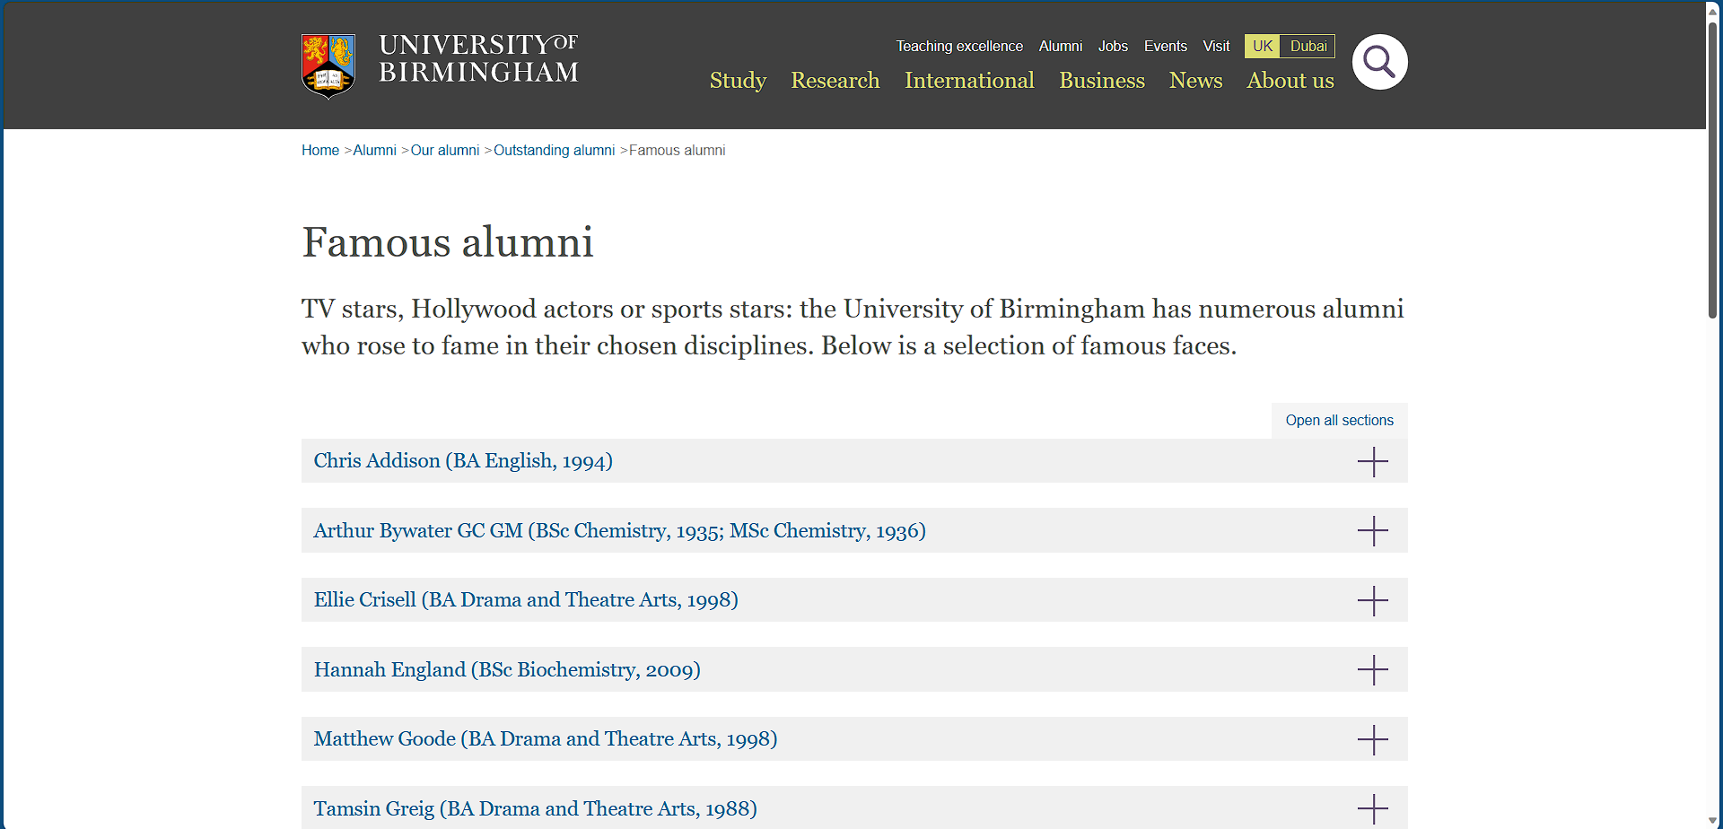

**Figure 1: Alumni page of University of Birmingham**

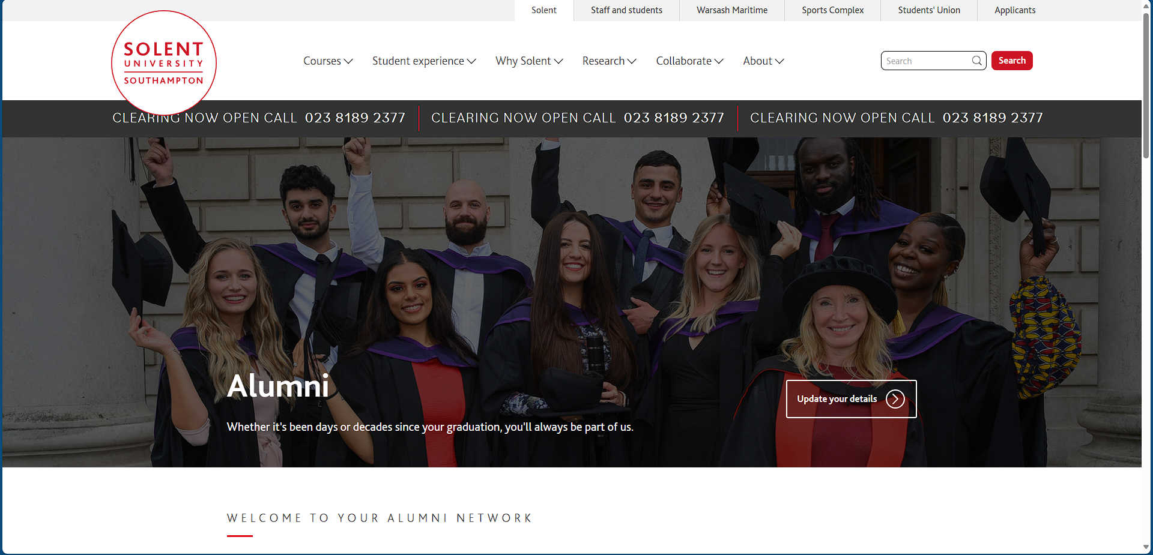

**Figure 2: Alumni page of Solent University**

# User research analysis

## Contextual interview

This section is mainly focussed on proper review as well as the analysis of the feedback gained from the users of the Solent University Alumni Association current website. The feedback of the users was accumulated through a contextual interview conducted with 10 former students of Solent University and responses were noted down for understanding what issues are being faced by the students and how improvements could be introduced in the website. Based on the contextual interview conducted in Appendix 1, it is being determined that the main users of the website are the former students of the Solent University who intends to stay updated about the news, opportunities and events being conducted by Solent University. The goals of the users is to access necessary information with minimum clicks on the website and complete their tasks easily without needing to deviate from the main page frequently.

Based on the survey conducted in Appendix 2, the user groups and the characteristics being defined for the Solent University Alumni Association current website are:

|  |  |  |  |  |
| --- | --- | --- | --- | --- |
| **User groups** | **Demographics** | **Geographic** | **Psychographic** | **Behavioural** |
| Graduate Students | Age: 21 and above  Years of education: 20 years  Income: £100K annually  Family size: 4 members  Gender: Any gender  Race: Any race  Marital status: Unmarried | Urban students  Radius: Within 100 km of the University  Amenities: basic amenities like food, clothing, water and air are available | Activities: Playing football, playing cricket, watching movies, listening to music  Interests: Engaging in online discussions, working with senior individuals to complete projects  Personality: Introvert, practical  Attitude: calm and calculative | Prefers to shop online through various eCommerce websites,  Frequent social media user  Follows sports brands and cheap brands |
| Post-graduate students | Age: 25 and above  Years of education: 25 years  Income: £200K annually  Family size: 4 members  Gender: Any gender  Race: any race  Marital status: Unmarried | Urban students  Radius: Within 100 km of the University  Amenities: basic amenities like food, clothing, water and air are available | Activities: watching movies, listening to music  Interests: Engaging in online discussions,  Personality: extrovert, Emotional  Attitude: Eager and persuasive | Prefers to shop online through various eCommerce websites,  Frequent social media user  Follows sports brands and cheap brands |
| Visitors | Age: 21 and above  Years of education: 20 years  Income: £100K annually  Family size: 4 members  Gender: Any gender  Race: any race  Marital status: Unmarried | Urban students  Radius: Within 100 km of the University  Amenities: basic amenities like food, clothing, water and air are available | Activities: Playing football, playing cricket,  Interests: Pursuing live projects  Personality: Introvert, practical  Attitude: calm and calculative | Prefers to shop online through various eCommerce websites,  Frequent social media user  Follows sports brands and cheap brands |

After determining the various user groups for the website of Solent University, the various user needs determined for the user groups are:

|  |  |
| --- | --- |
| **User groups** | **User needs** |
| Graduate Students | View information about Alumni on the homepage of the website  View information about news, events and opportunities in the University on the homepage (Albert and Tullis 2022)  Browse through the website without being disturbed by the automated drop-down feature of the navigation menu  View clear information on the website and no information should be hidden behind the logo of the organization (Johnson 2020) |
| Post-graduate students | View information about news, events and opportunities in the University on the homepage  Connect with other alumni through online discussion platform  Check information about the faculty of the University (Bate and Robert 2023) |
| Visitors | Connect with other alumni through online discussion platform  Check information about the faculty of the University |

# User journey

## User Persona

**Persona 1: Former graduate student**

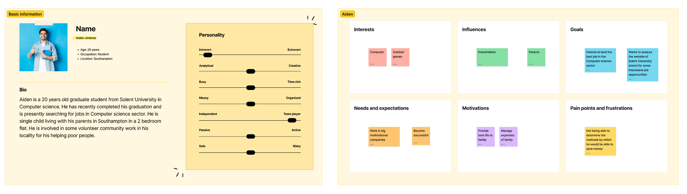

*https://www.figma.com/file/GqVbCXizdh22GKhDJpJLJR/User-persona-1?type=whiteboard&node-id=0-1&t=1xOYRmVQNC3DM3KG-0*

**Persona 2: Visitor**

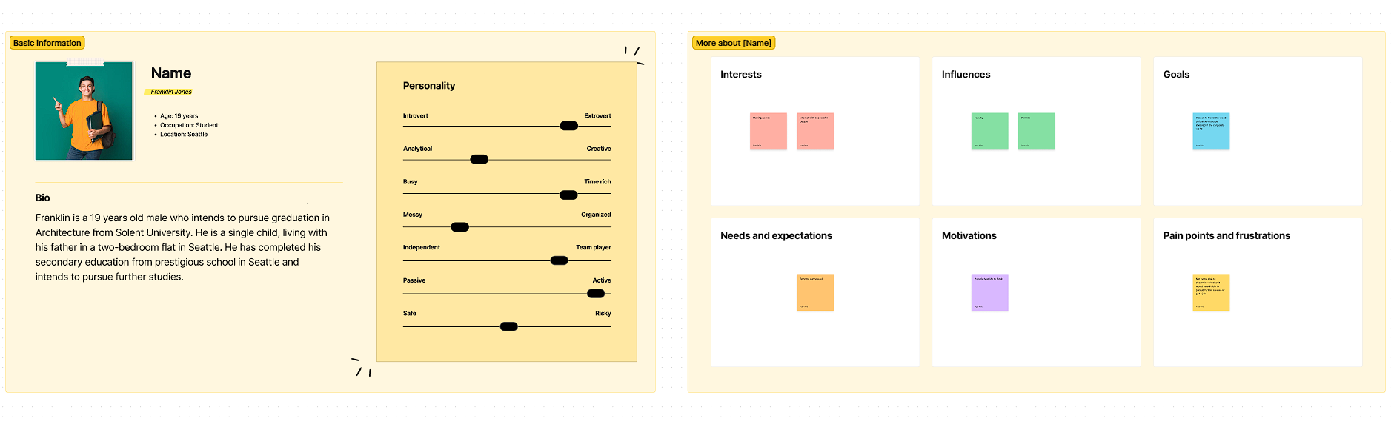

https://www.figma.com/file/Po73GruTV9BX70akQ1Qs1T/User-persona-2?type=whiteboard&node-id=0-1&t=fVeatBXcrUGzQTNs-0

## User Scenario

Scenario 1:

Former graduate student visits the website for checking information about the upcoming events being organized by Solent University for the recent years graduates.

Scenario 2:

New students checking information about the quality and standard of the alumni of the University before taking admission in the University.

## User Goals

As a user, I want to use the system for checking information about the past alumni of the University and view information about how the University has shaped future of students.

As a graduate student, I want to use the system for checking the opportunities and events being organized by the University for delivering better future of the students (Liao, Gruen and Miller 2020).

As a post-graduate student, I want to use the system for checking information about the seminars being conducted and invitations received for delivering speech in seminar.

As a user, I want to use the system for registering for receiving duplicate of degree certificate from the University (Bodker 2021).

## Information Architecture

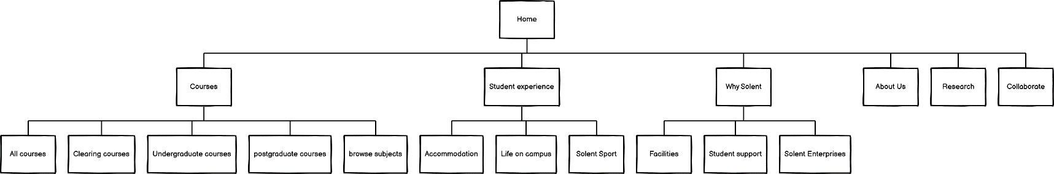

## Empathy Mapping

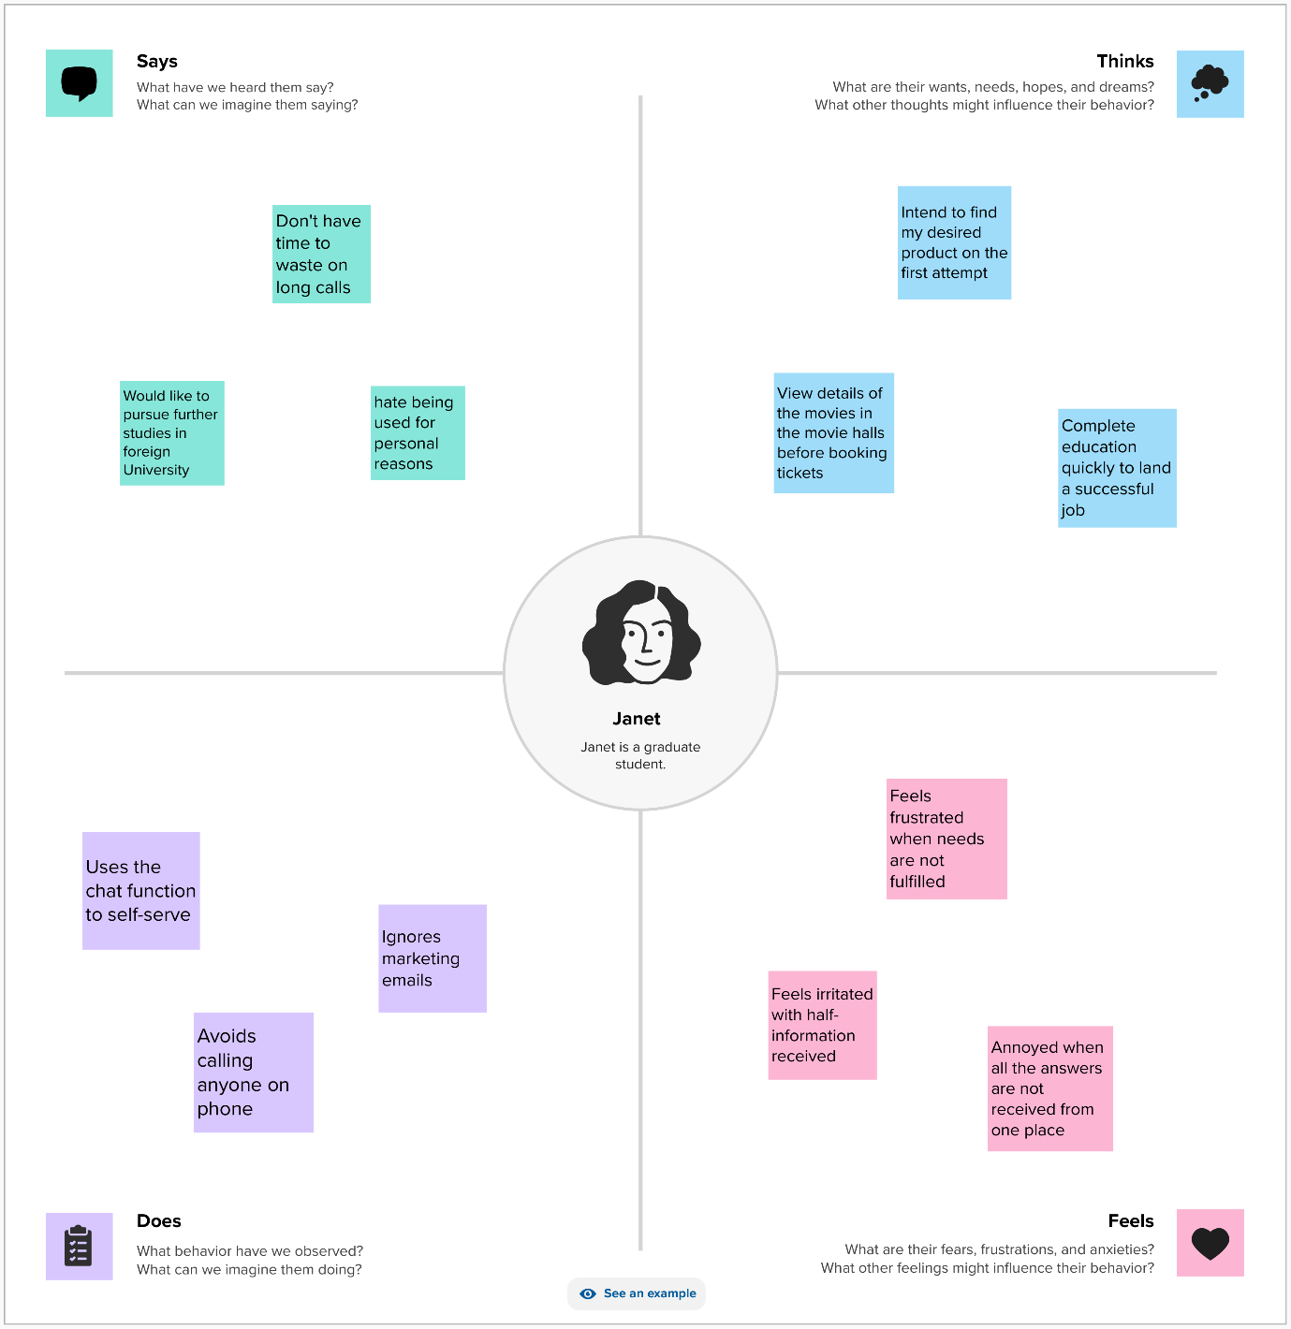

## Usability Metrics

The usability metrics being considered for determining whether the prototype is working effectively or not are:

Navigation: The navigation usability metric is being considered for determining whether the users are able to navigate through the various pages of the website easily without facing major issues and clear information is being viewed from the pages (Wang et al. 2021).

Data entry: The data entry usability metric is being considered for determining whether the website allows the users to enter their data easily according to the pre-defined format and no other data is being accepted by the website (Cheng and Jin 2019).

Layout: The layout usability metric is being considered for determining whether the structure of the website is adapative according to the devices where it is being opened and whether all the information is being clearly displayed to the users (Bier et al. 2023).

Terminology: The terminology usability metric would help in determining whether the appropriate terms and naming conventions are being followed in the website or not. It would help in determining whether the users are being provided with the sufficient guidance to understand how the various elements are being placed in the website.

Comprehension: The comprehension usability metric would help in determining whether the users are able to understand all the instructions being presented on the website and complete their tasks without requiring major guidance about using the website.

Feedback: The feedback usability metric would help in determining whether the website is providing accurate feedback for the tasks being completed by the users and whether the feedback is according to the expectations of the users while completing the tasks.

# Prototype

# Usability testing

10 former students of Solent University were recruited for conducting the usability testing and responses were noted down for understanding what issues are being faced by the students and how improvements could be introduced in the website. The usability testing of the new website of Solent University Alumni website determined whether the website is usable for the people or not. The first question asked to the testers was that whether they were able to navigate through the pages of the website through clicking on the appropriate links on the website. 60% of the respondents claimed that the website has the efficient functionality of allowing the users to navigate through the pages of the website without facing major issues. 30% of the respondents claimed that they faced some issues while navigating through some of the crucial elements on the website due to the size of the links being used on the website. The improvements have been done in the interface design based on customer feedback to ensure that the usability of the website would be increased. The next question asked to the participants of usability testing was whether they faced issues while entering data in the data entry form presented on the website of Solent University Alumni. 50% of the respondents claimed that the website does not provide any instruction on the type of data to be entered in the data entry form and it caused major issues for the users. 30% of the respondents claimed that it was rather easy to enter data in the data entry form and all the data was accurately entered in the first attempt. The required modifications have been done on the data entry form according to the instructions. The next question that was asked of the participants was to determine whether the instructions were presented on the website in rather simple plus understandable language for the users. More than 50% of the participants claimed that the website presents all the necessary instructions in easily understandable language and easily understood by the users. It could be determined that the website is interacting with the users in understandable language and tasks can be easily completed on the website. The next question asked of the participants whether the users received proper feedback from the website each time they clicked on the elements of the website. 50% of the respondents claimed that the website is efficiently providing feedback each time the users would click on any element on the website. It helps in improving the overall accessibility of the website and helped in improving the overall usability of the website. Providing feedback for each step of the tasks helped in assuring the users that the correct path of completing task is being followed. The next question asked of the participants was to determine whether they are able to properly understand all the terminologies being utilised in new website of Solent University Alumni. 40% of the participants rated the simplicity of understanding the terminologies as 4, which denotes that all the terms being used in the website is rather easily understandable by the users and mistakes cannot be made by the users to understand the meaning of the words on the website. The next question asked of the users was to determine how easily the necessary elements for their tasks on the website was determined. 40% of the participants claimed that the all necessary elements on the website is clearly stated on the main pages of the website and it helps in easily completing the tasks on the website. Overall, it is being determined that the website is usable and is a significant improvement over the existing Solent University Alumni website because the new website is eliminating all the issues faced by the users while using the existing website.

# Conclusion

Therefore, the conclusion is determined from the above discussion that the implementation of the new Solent University Alumni website would help eliminate the issues of the existing interface design and deliver improved capabilities to the users to complete their tasks. The usability testing of the new website is being completed in this report which helps in understanding whether the new website is able to function according to the requirements of the users or not. The prototype design is being completed in this report for the new website design that incorporates all the user needs and requirements determined through user research.

# References

Albert, B. and Tullis, T., 2022. Measuring the User Experience: Collecting, Analyzing, and Presenting UX Metrics. Morgan Kaufmann.

Bate, P. and Robert, G., 2023. Bringing user experience to healthcare improvement: the concepts, methods and practices of experience-based design. CRC Press.

Bier, E.A., Stone, M.C., Pier, K., Buxton, W. and DeRose, T.D., 2023. Toolglass and magic lenses: the see-through interface. In Seminal Graphics Papers: Pushing the Boundaries, Volume 2 (pp. 59-66).

Bodker, S., 2021. Through the interface: A human activity approach to user interface design. CRC Press.

Cheng, M. and Jin, X., 2019. What do Airbnb users care about? An analysis of online review comments. International Journal of Hospitality Management, 76, pp.58-70.

Johnson, J., 2020. Designing with the mind in mind: simple guide to understanding user interface design guidelines. Morgan Kaufmann.

Liao, Q.V., Gruen, D. and Miller, S., 2020, April. Questioning the AI: informing design practices for explainable AI user experiences. In Proceedings of the 2020 CHI conference on human factors in computing systems (pp. 1-15).

Wang, V., Xu, N., Liu, J.C., Tang, G. and Geng, W.T., 2021. VASPKIT: A user-friendly interface facilitating high-throughput computing and analysis using VASP code. Computer Physics Communications, 267, p.108033.

# Appendices

## Appendix 1: Contextual interview

Me: What did you enjoy about using the Solent University Alumni Association's current website?

Interviewee: I really liked the fact that the website has maintained the principle of simplicity to display all information on the website without making the information searching process rather complex.

Me: What issues did you face while browsing the Solent University Alumni Association's current website?

Interviewee: Even though the Solent University Alumni Association's current website has been developed rather efficiently, there are some underlying issues with the Solent University Alumni Association's current website that need to be eliminated. The primary issue I faced was that the drop-down button beside each menu item opened automatically and confused me into making proper selections on the page. One more issue faced was that the logo of the Solent University Alumni Association's current website is masking crucial information about the clearing and information is being hidden behind the logo.

Me: When might you use the Solent University Alumni Association's current website?

Interviewee: I would most likely use the Solent University Alumni Association current website when I intend to learn about the past alumni of the University before I am planning to take admission in the University. I would also use the Solent University Alumni Association current website when I need to provide information about the alumni to any other individual who intends to pursue further studies in the University.

Me: Would you use the Solent University Alumni Association current website for personal or even professional reasons?

Interviewee: I would use the Solent University Alumni Association current website for personal reasons for understanding the quality and standards of the past alumni of the University before I would take admission in the University. I would like to use the Solent University Alumni Association current website for being updated with the latest news, the events and the opportunities.

Me: What would make you choose the Solent University Alumni Association current website over other websites?

Interviewee: As I am a former student of Solent University, I would feel rather connected with the alumni website and would understand the information clearly that is being presented about the past alumni of the University.

## Appendix 2: Survey

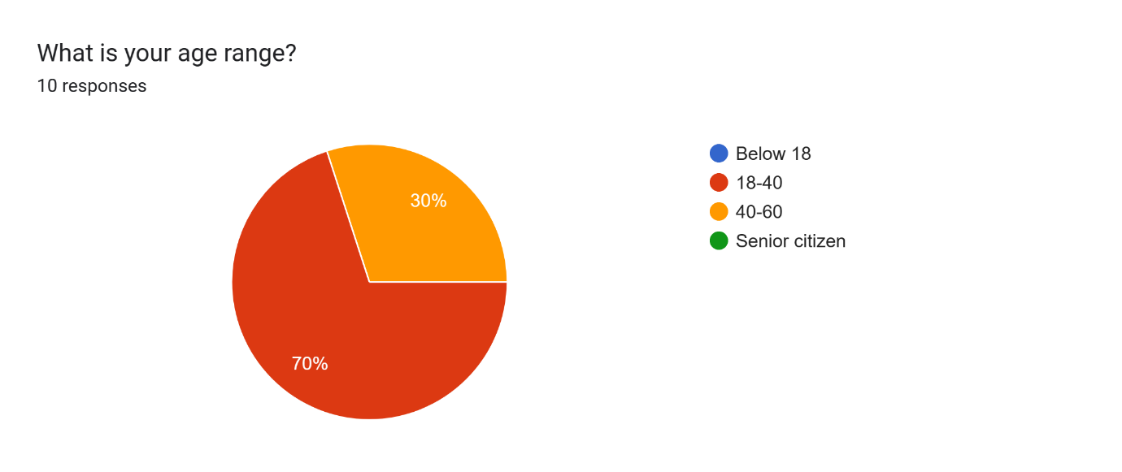

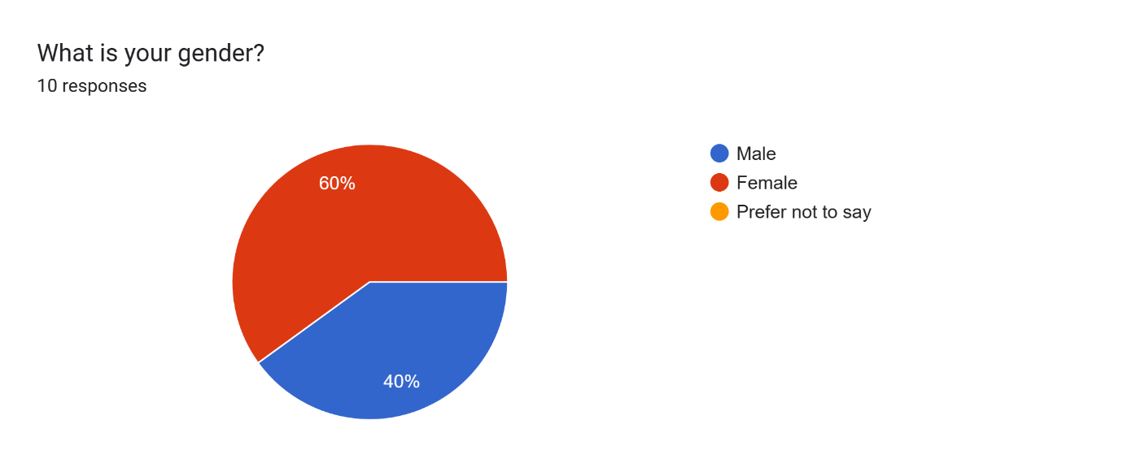

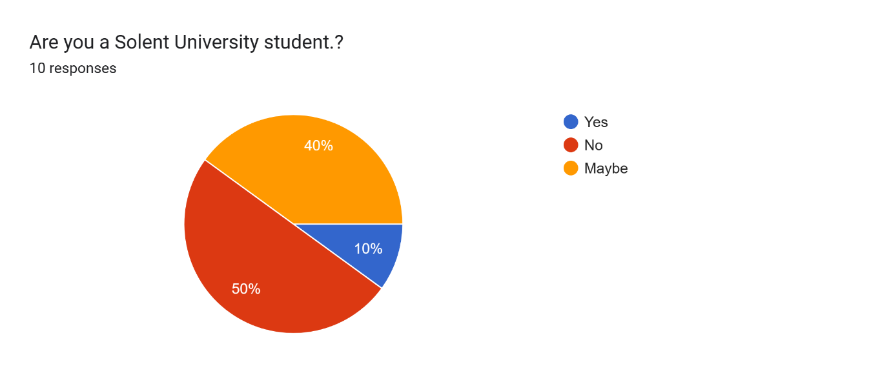

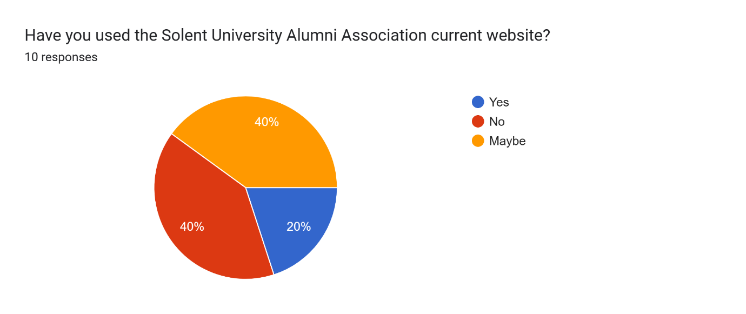

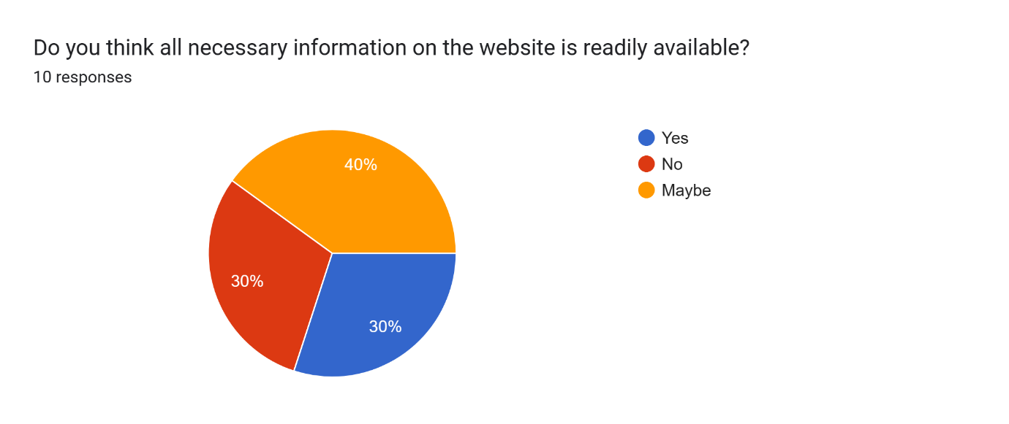

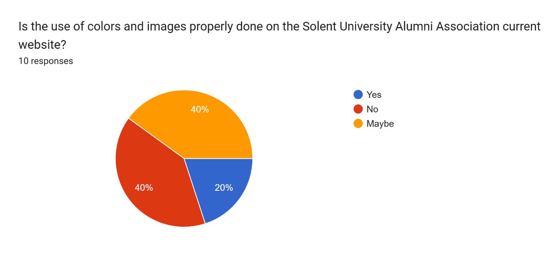

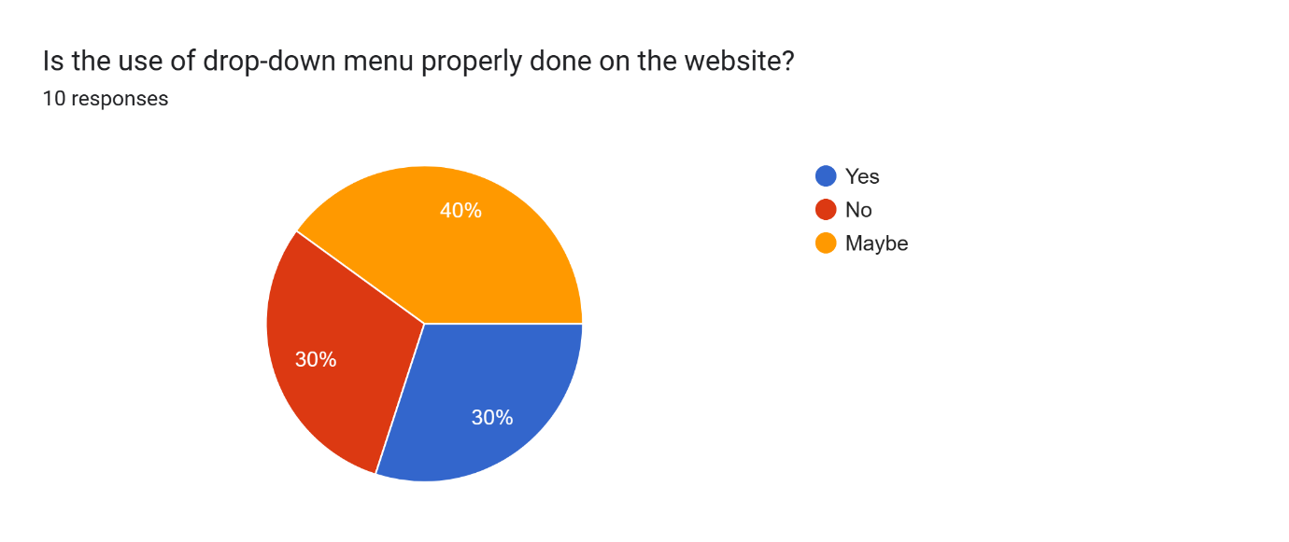

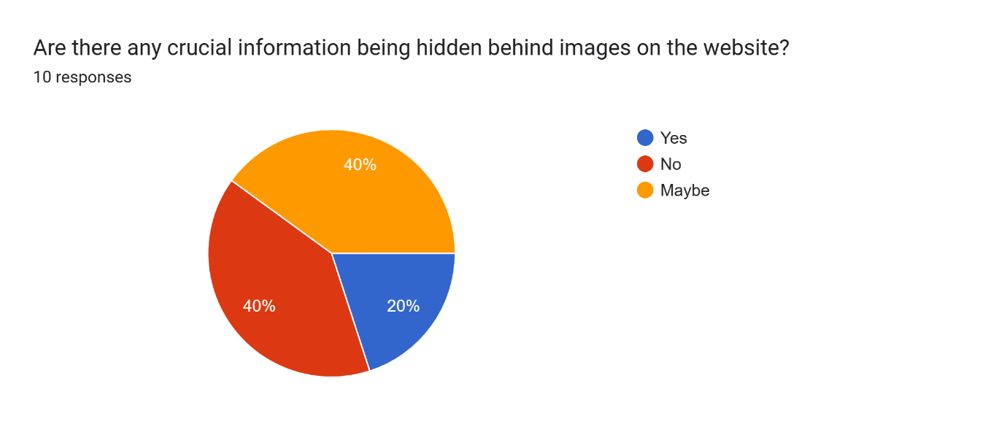

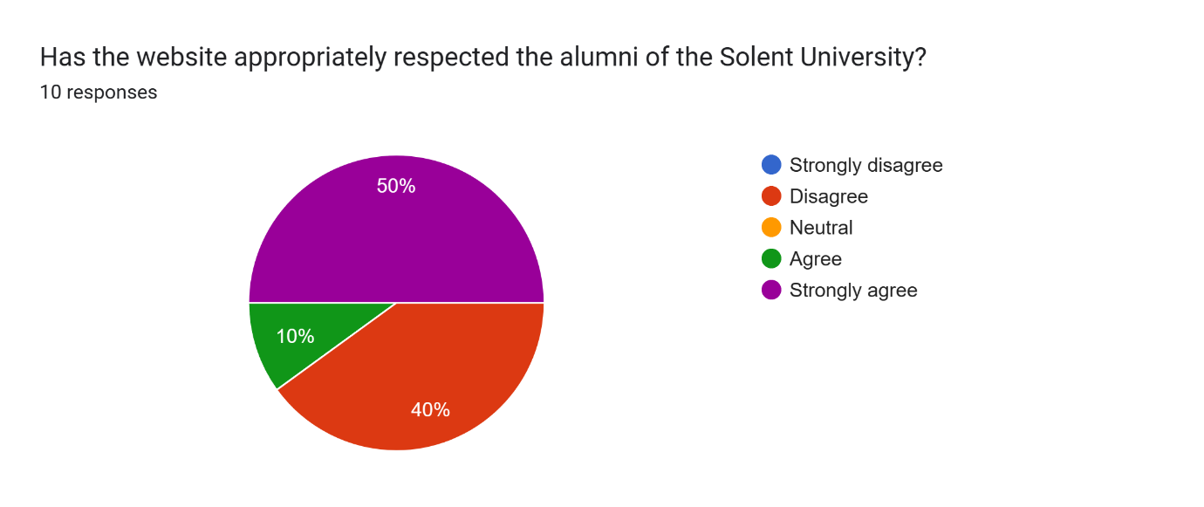

## Appendix 3: Usability testing

